Model Development Phase Template

|  |  |
| --- | --- |
| Date | 14th July 2024 |
| Team ID | 739959 |
| Project Title | SENTIMENTAL ANALYSIS OF COMMODITY NEWS (GOLD) |
| Maximum Marks | 4 Marks |

**Initial Model Training Code, Model Validation and Evaluation Report**

The initial model training code will be show cased in the future through a screenshot. The model validation and evaluation report will include classification reports, accuracy, and confusion

matrices for multiple models, presented through respective screenshots.

**Initial Model Training Code:**

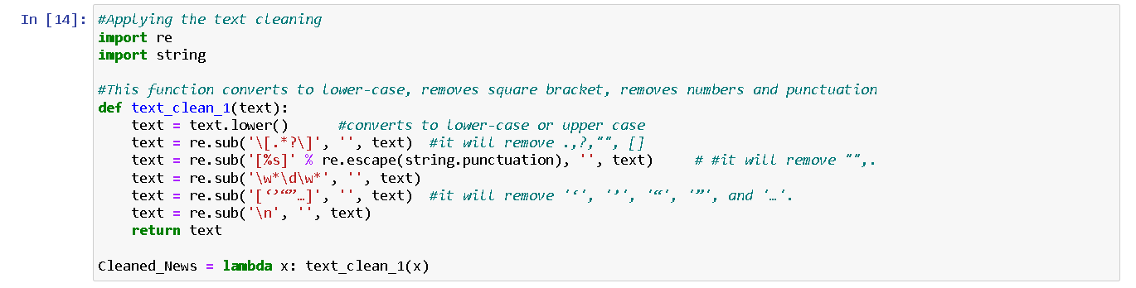

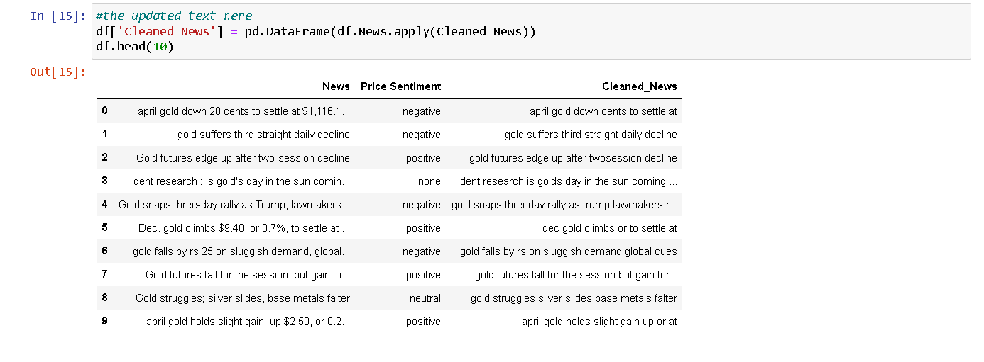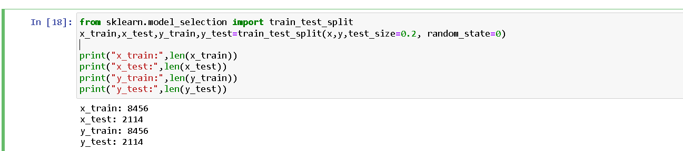

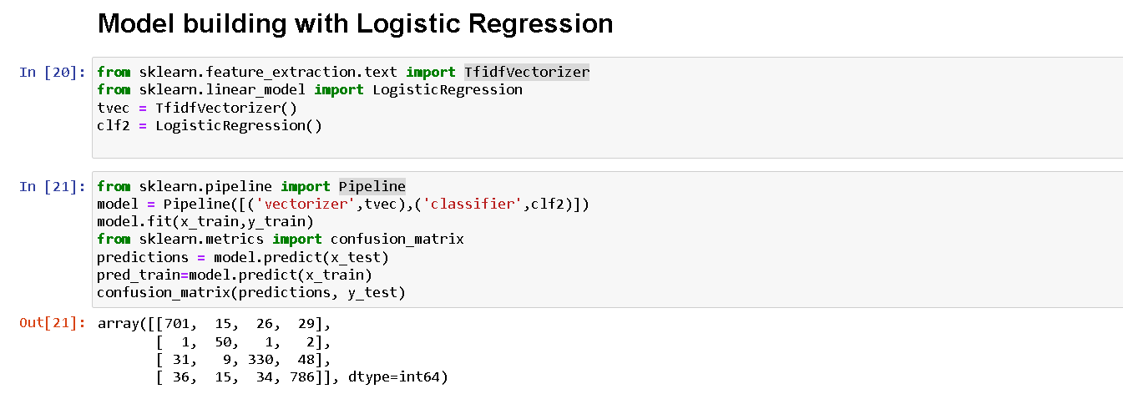

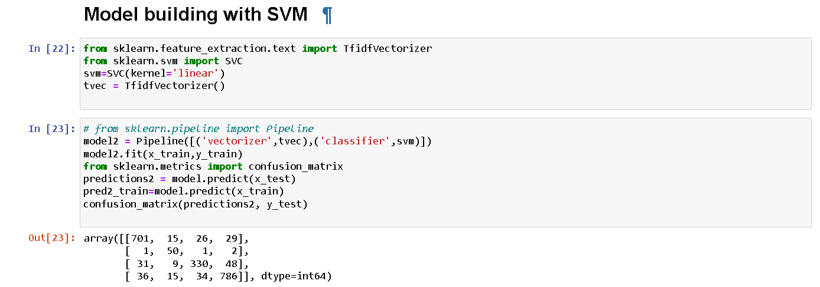

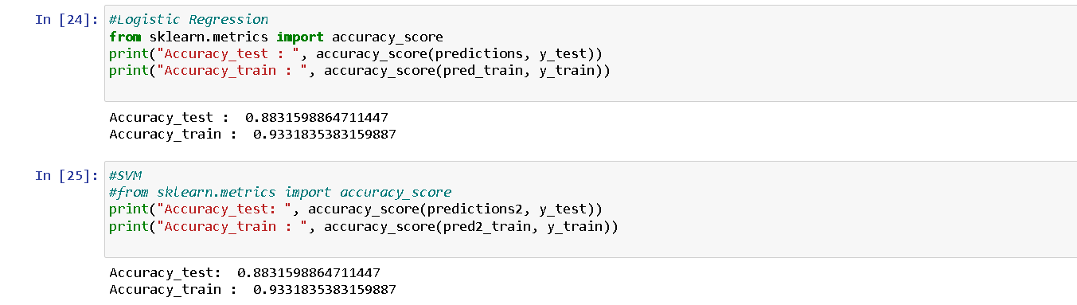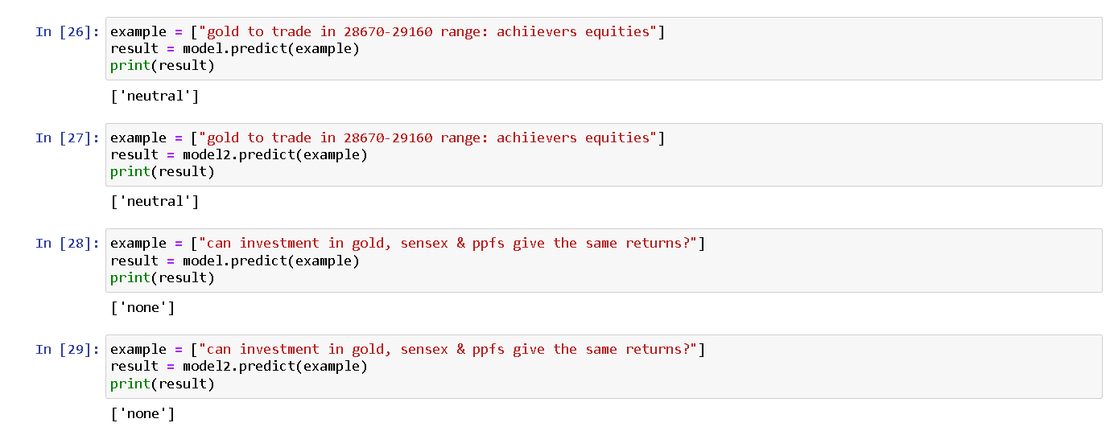

**Model Validation and Evaluation Report:**

|  |  |  |  |
| --- | --- | --- | --- |
| **Model** | **Classification Report** | **F1**  **Scor e** | **Confusion Matrix** |
| LOGISTIC REGRESSION | C:\Users\DELL\Desktop\images\image18 (1).png | 88% | C:\Users\DELL\Desktop\image22.png |

|  |  |  |  |
| --- | --- | --- | --- |
| SUPPORT  VECTOR  MACHINE | https://lh4.googleusercontent.com/IDaQMbrHOrPOJtvRnNzFkhiZgGNWQBtyKLPG2bbuFeLKIiInYz46T3kvPZPrAVBjVztC1TXjgq5yWKscPj6T1-LgeBAP_PQ0eIZSWu25h17srbha1eXeBPA-lDMWCS0DHssztMTUOYypl23suBTBRA | 88% | C:\Users\DELL\Desktop\ABB.png |